Marwadi University
Faculty of Engineering & Technology
Department of Information and Communication Technology
  Subject: Digital Signal and  Image Processing (01CT1513) | Aim: Simulate discrete time sequences.
Experiment No: 1 | Date: 20-07-2026 | Enrollment No: 92400133161

Aim: Simulate discrete time sequences.

Program-1

import numpy as np
import matplotlib.pyplot as plt

n = np.arange(-4,5)
x = []
for i in n:
if i == 0:
x.append(1)
else:
x.append(0)

plt.stem(n,x)
plt.title("1. Impulse Function Graph")
plt.grid()
plt.show()

Output-1

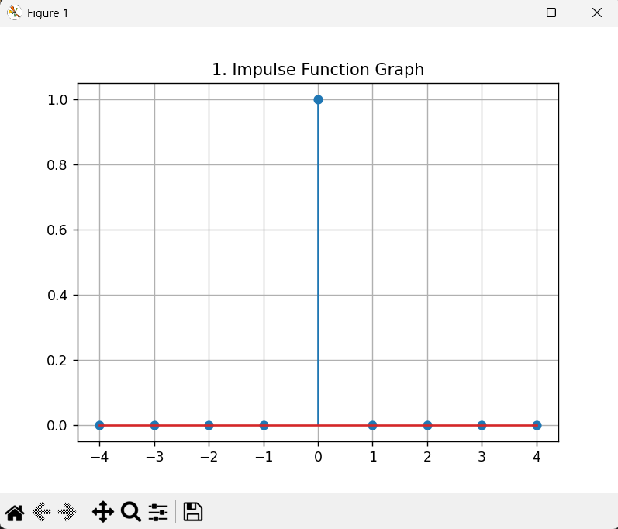

Program-2
n = np.arange(-4,5)
x = []
for i in n:
if i >=0:
x.append(1)
else:
x.append(0)
plt.stem(n,x)
plt.grid()
plt.title("2. Unit Step Function")
plt.xlabel("x")
plt.ylabel("x[n]")
plt.show()

Output-2
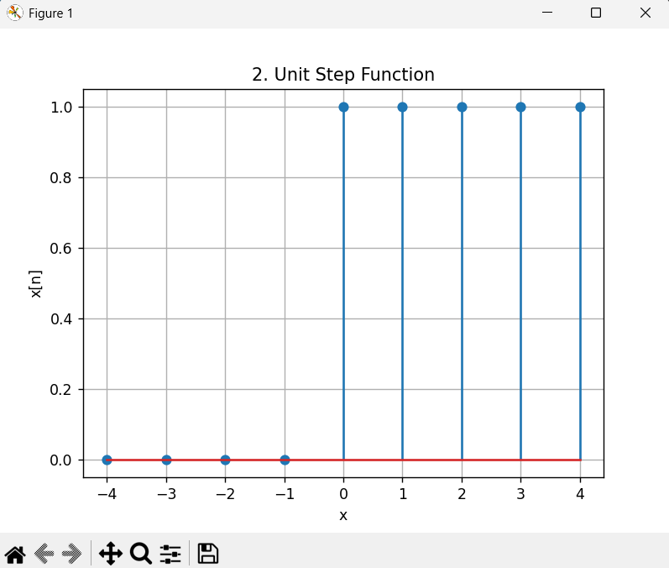

Program-3

n = np.arange(-4,5)
x = []
for i in n:
if i >=0:
x.append(i)
else:
x.append(0)
plt.stem(n,x)
plt.grid()
plt.title("3. Unit Ramp Function")
plt.xlabel("x")
plt.ylabel("x[n]")
plt.show()

Output-3

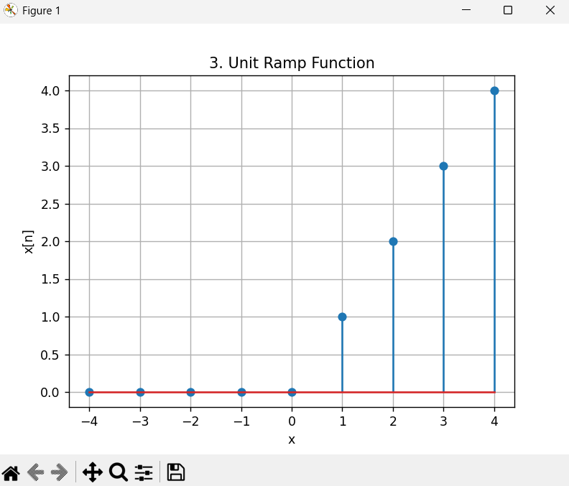

Program-4

n = np.arange(1,11)
x = []
for i in n:
x.append(2**i)
plt.stem(n,x)
plt.grid()
plt.title("4. Exponential Function")
plt.show()

Output-4
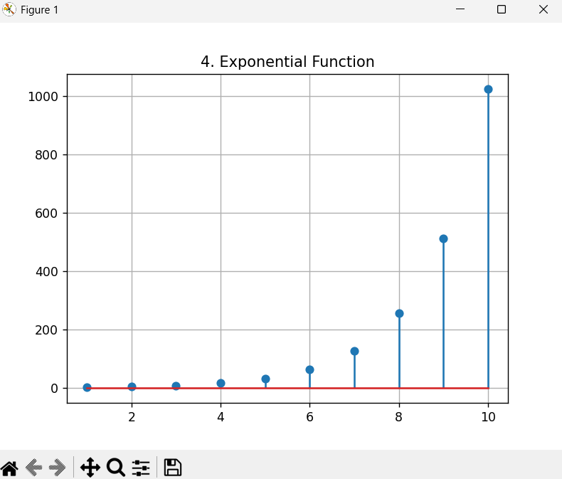

Program-5

n = np.arange(1,21)
x=[]
for i in n:
x.append(np.sin(i))
plt.stem(n,x)
plt.grid()
plt.title("5. Sinusoidal Function")
plt.show()

Output-5

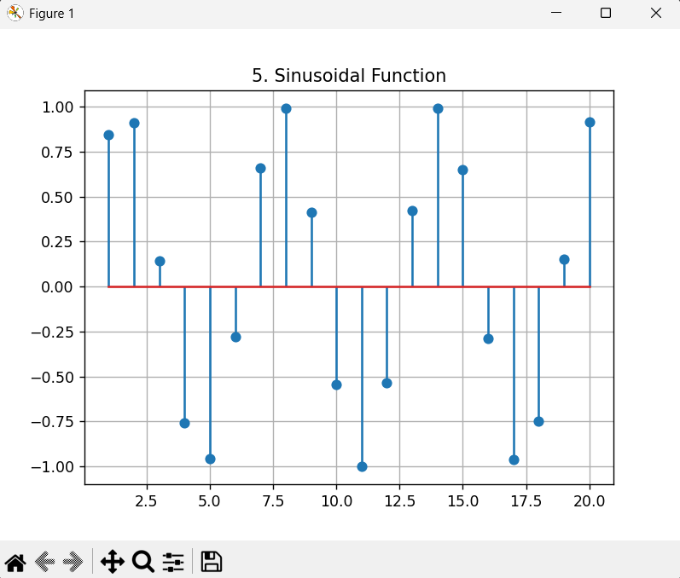

Conclusion:
Discrete time sequence simulation has been done using Python programming language. Sequences such as unit impulse, unit step, unit ramp, exponential, and sinusoidal have been generated and plotted using NumPy and Matplotlib libraries in Python. This exercise gave a better insight into the properties and plotting of various discrete-time signals in Signals and Systems.

